**Praktikum 2 Sistem Basis Data 2023**

**NRP / Nama : 5025221161  
Kelas : J**

**RDBMS : MySQL**

**Link SQL :** [**https://drive.google.com/drive/folders/15VNv7eX6J7F-oKz85fqtttNJkbgoc_x4?usp=sharing**](https://drive.google.com/drive/folders/15VNv7eX6J7F-oKz85fqtttNJkbgoc_x4?usp=sharing)

**Kode Asdos : SBDJ02**

**Sesi : Modul Pendahuluan**

**Nomor 1**

Sintaks:

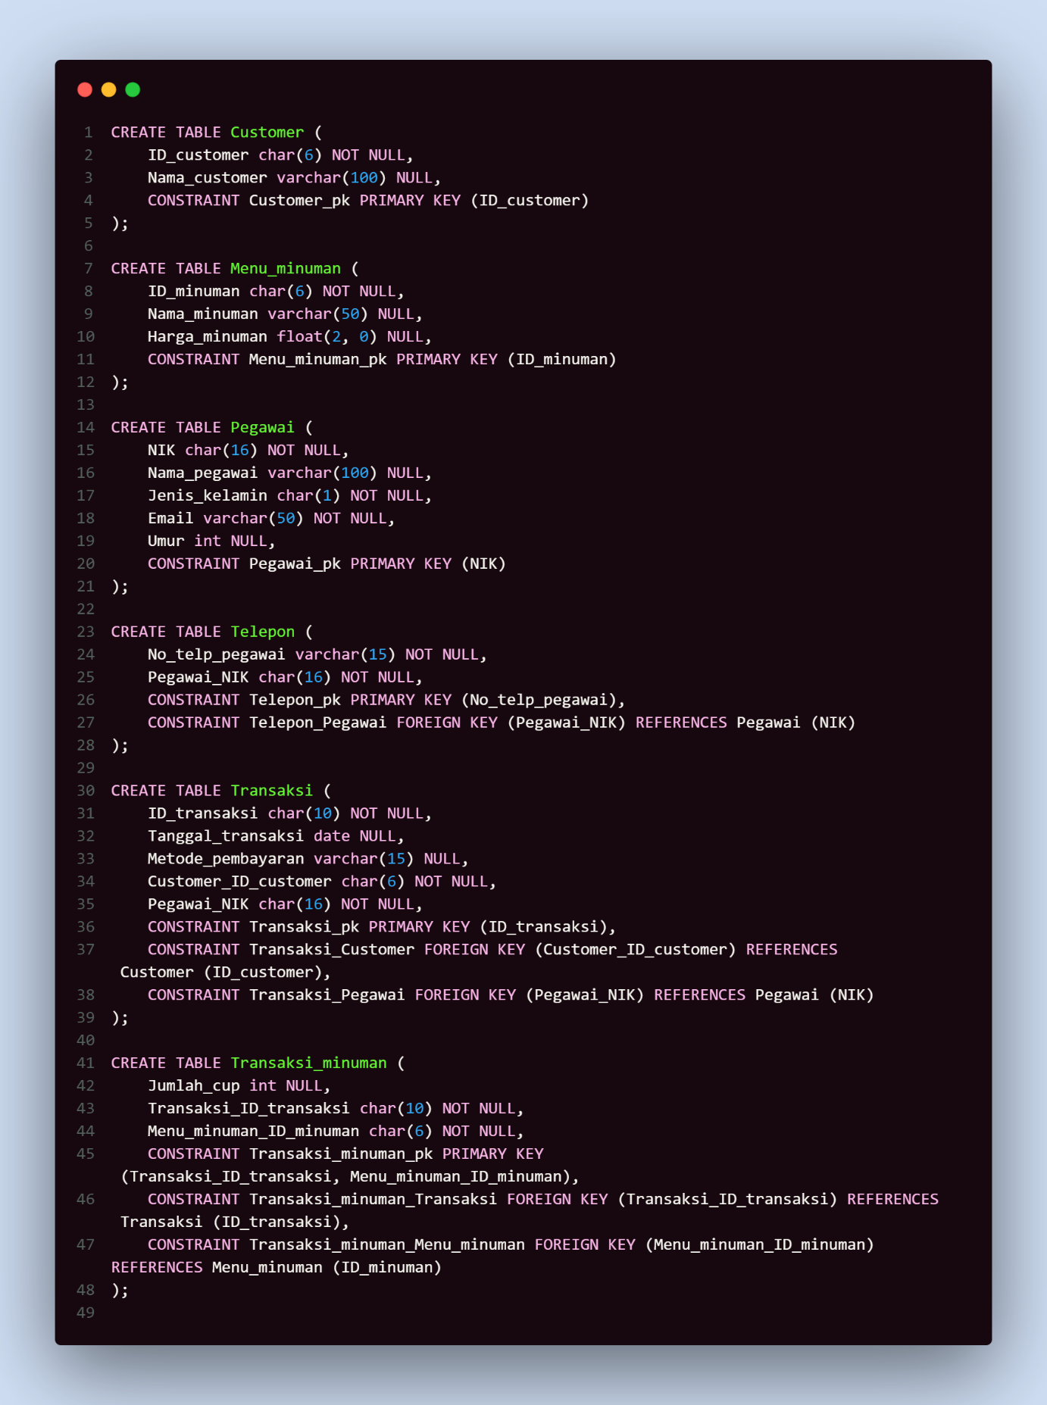

Hasil:  
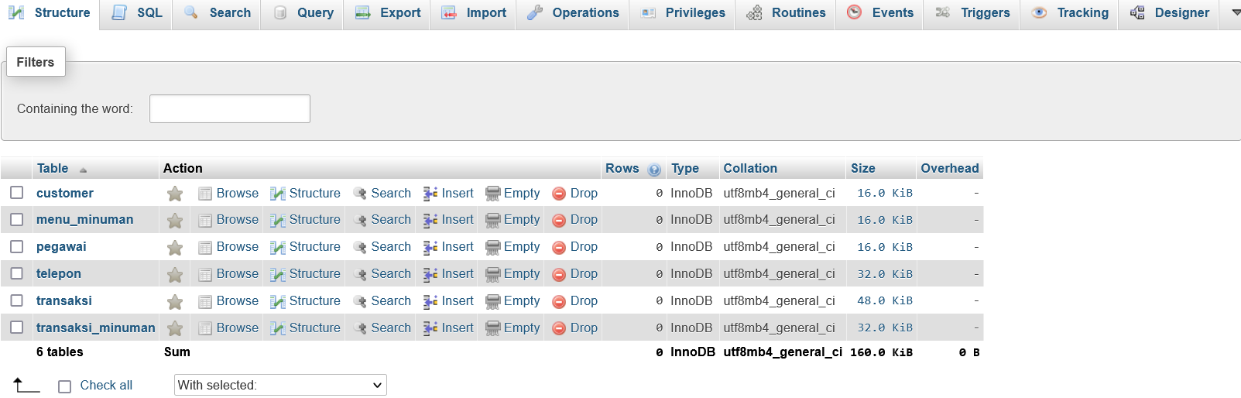

**Nomor 2**

Sintaks:

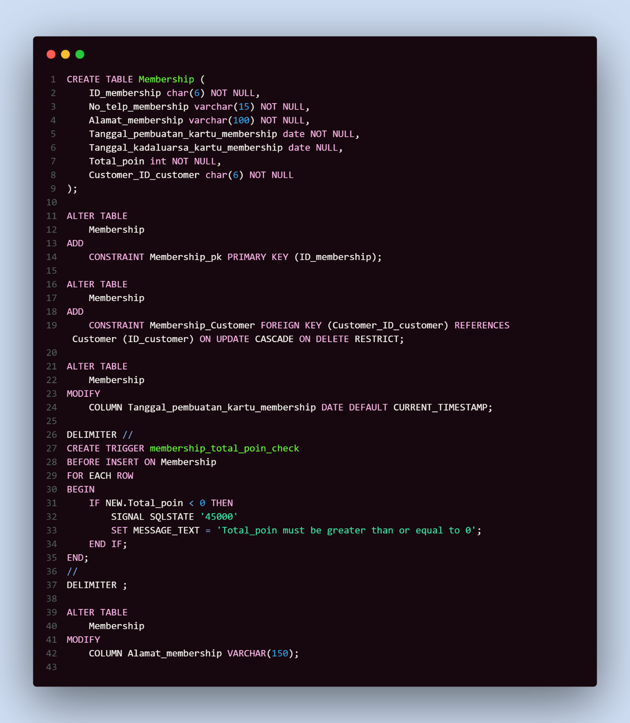

Hasil:  
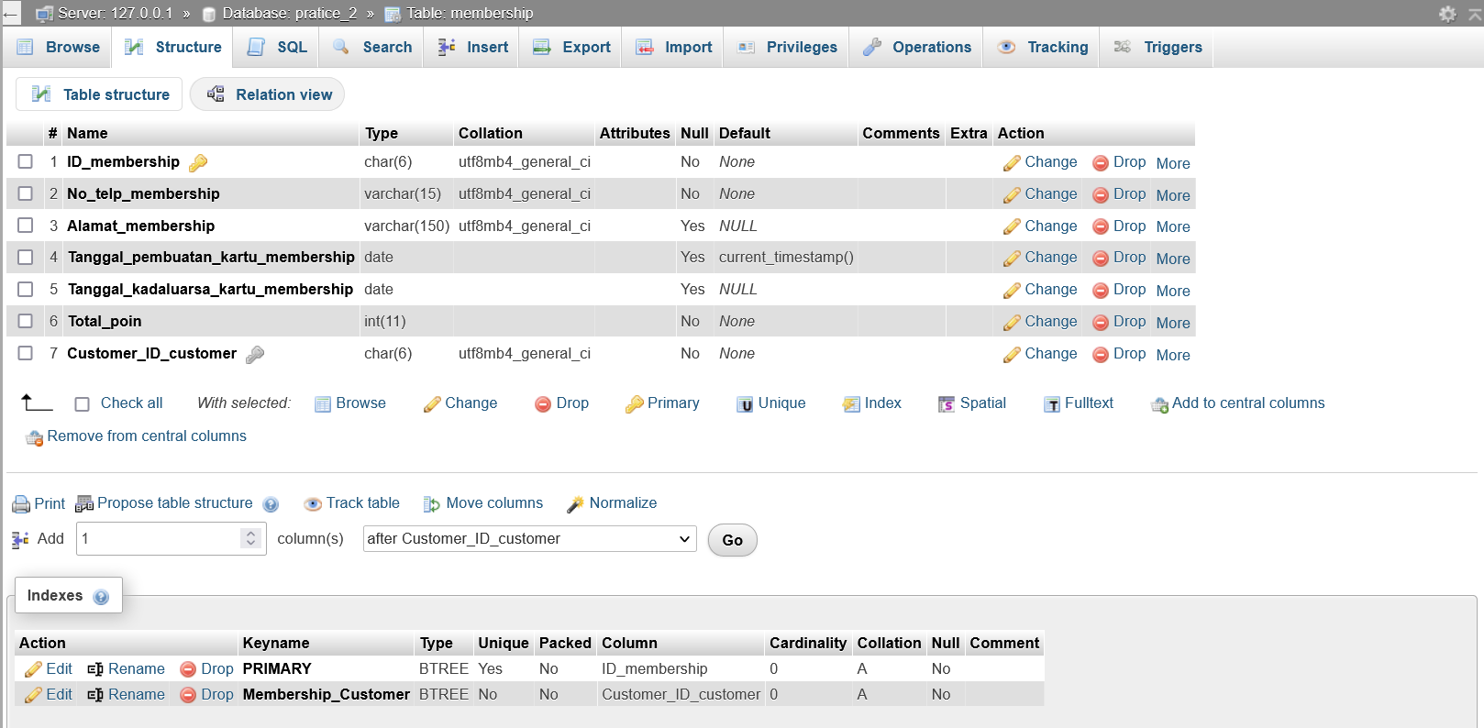

**Nomor 3**

Sintaks:

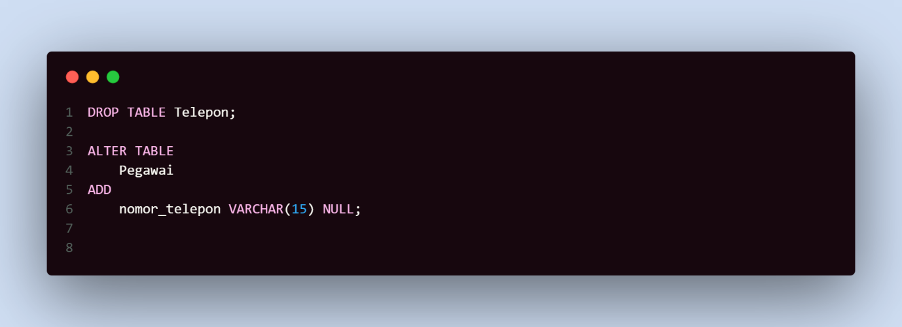

Hasil:

Nomor telepon deleted  
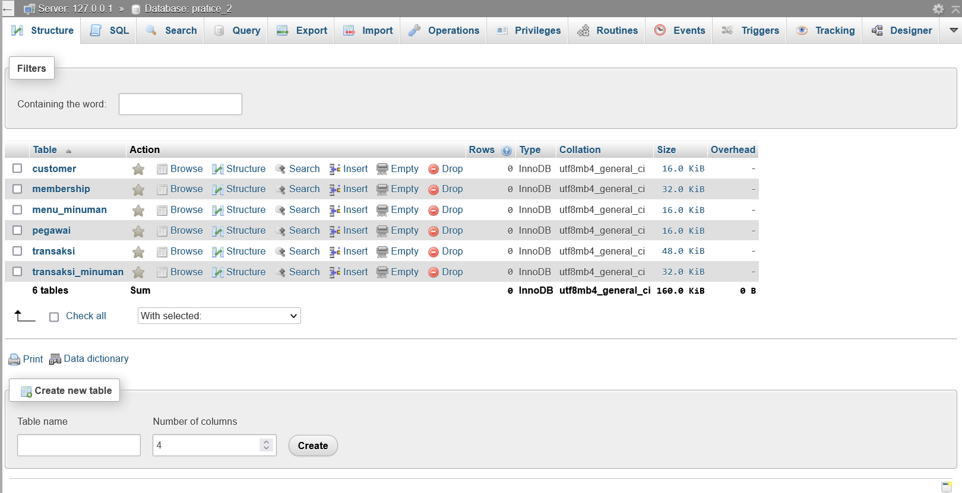

Pegawai updated  
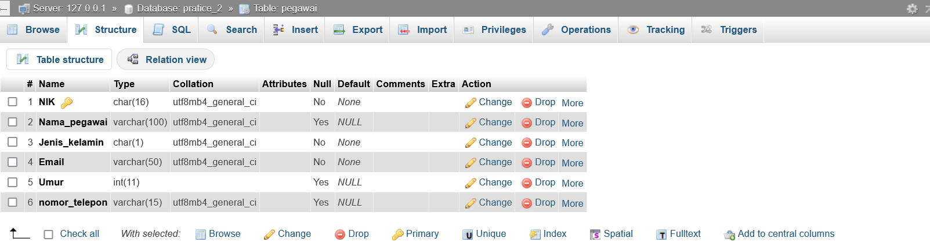

**Nomor 4**

Sintaks:

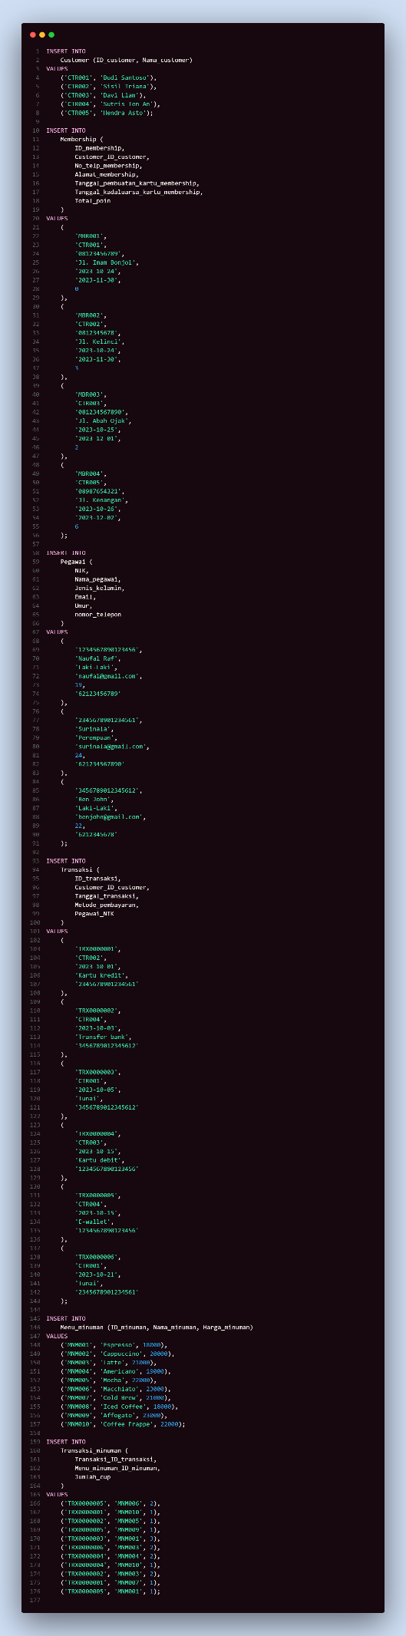

Hasil:

Customer  
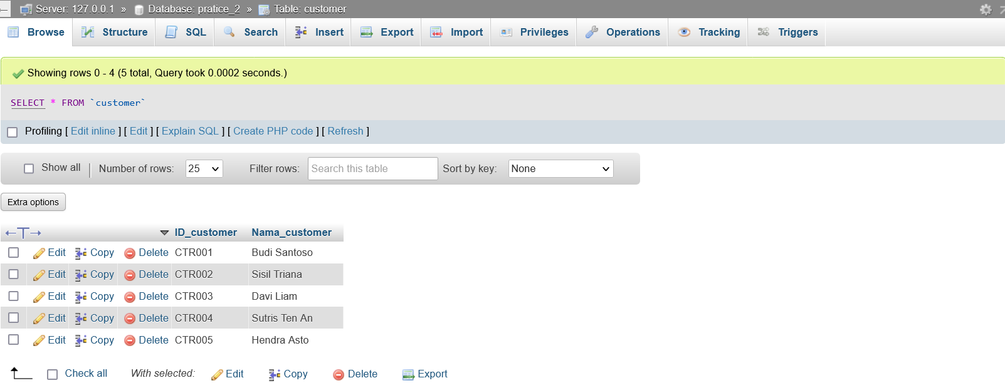

Membership  
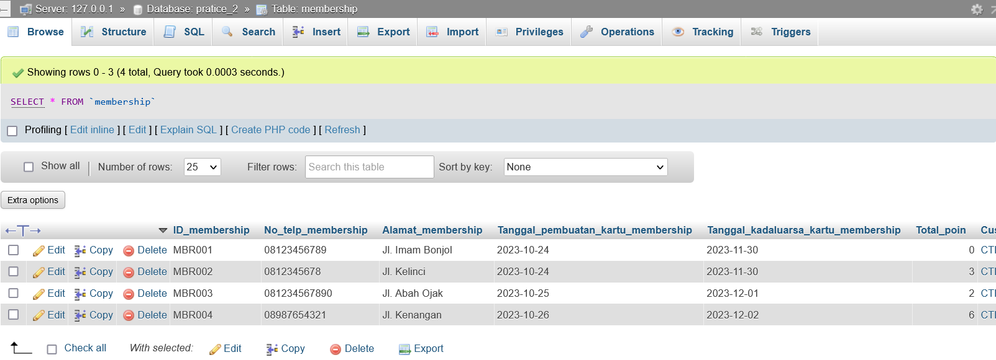

Pegawai  
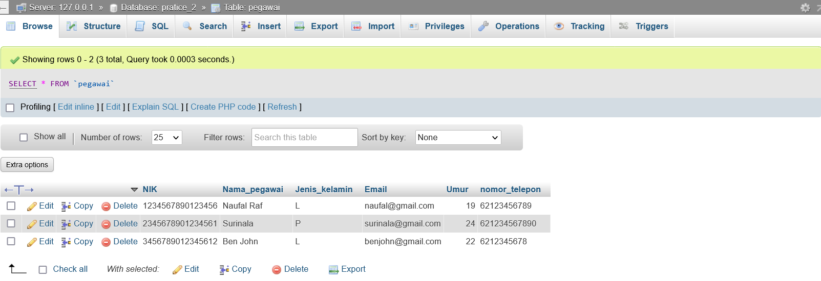

Transaksi  
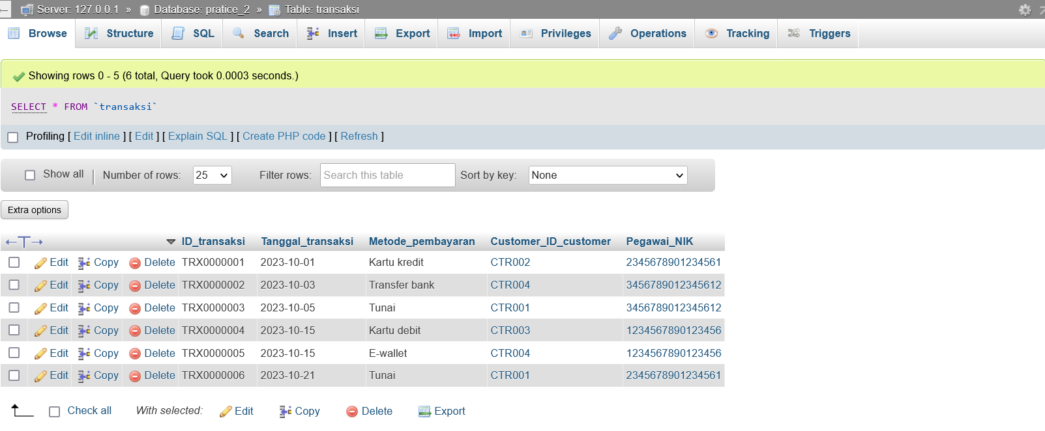

Menu Minuman  
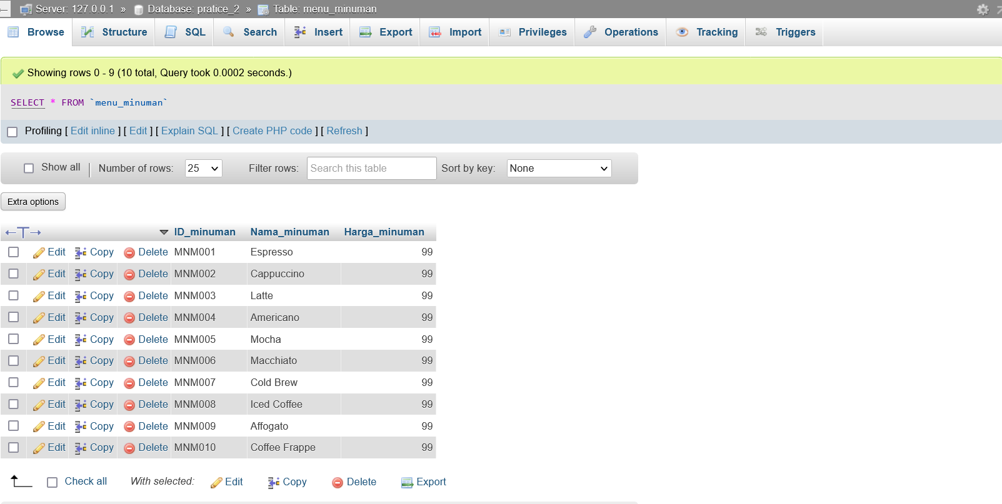  
Transaksi Minuman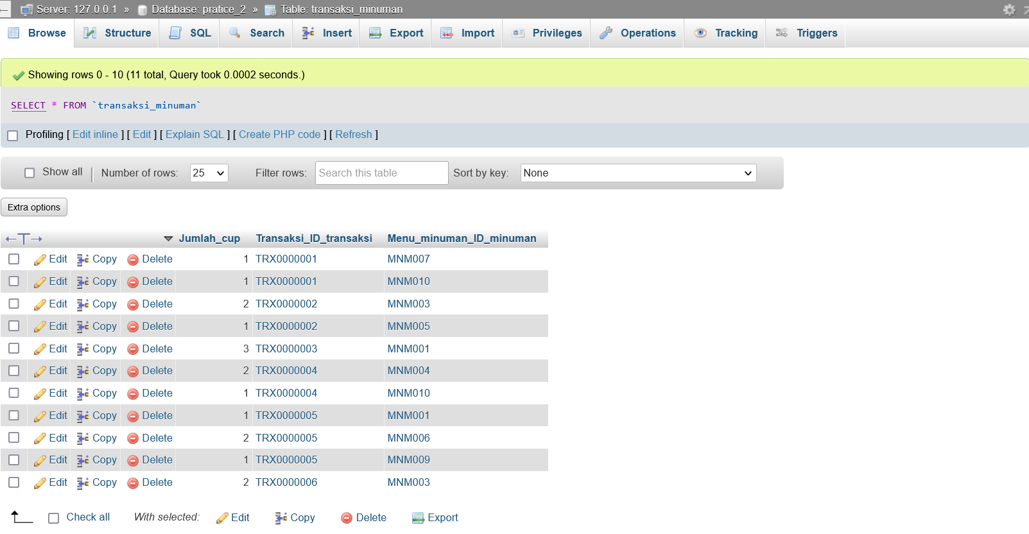

**Nomor 5**

Sintaks:

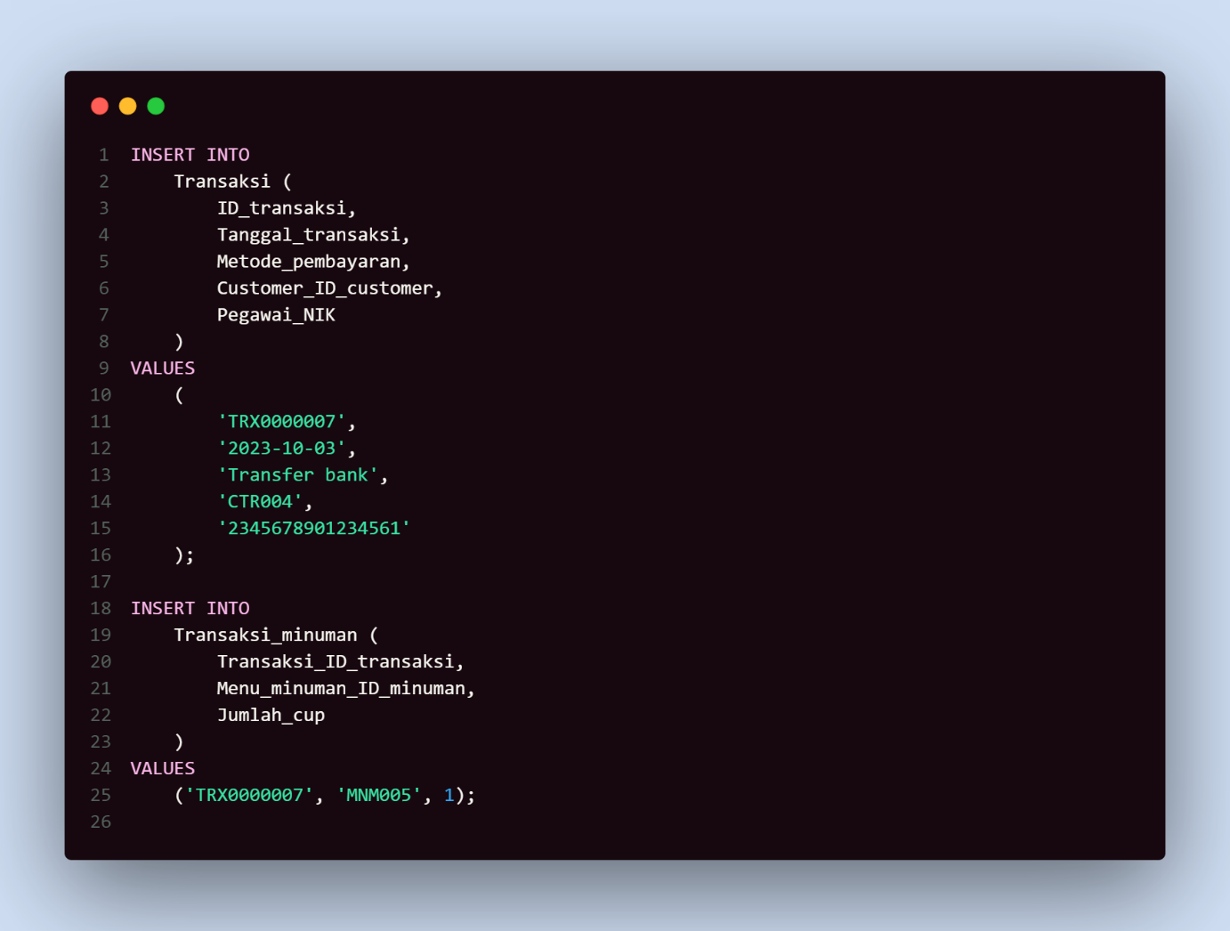

Hasil:

Transaksi updated  
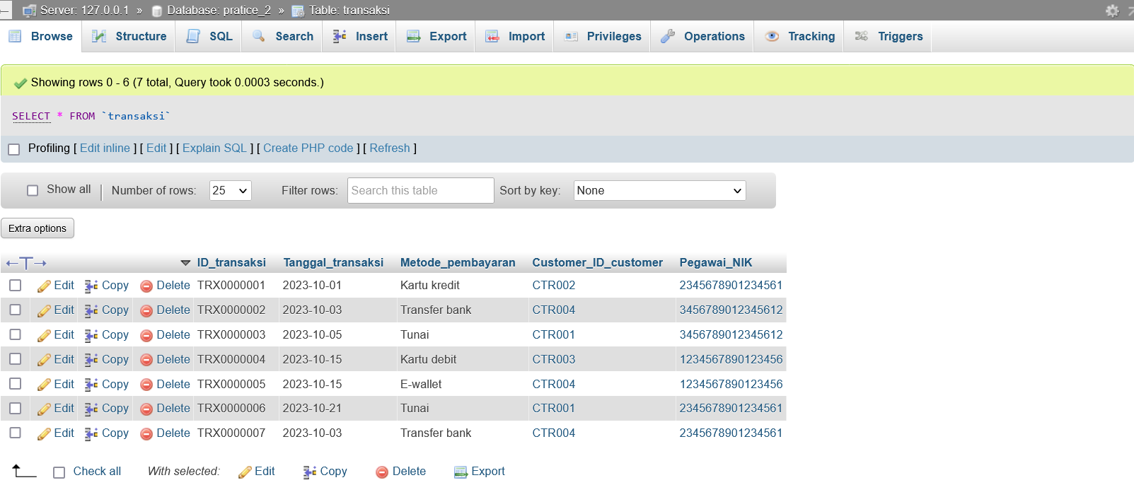

Transaksi Minuman updated  
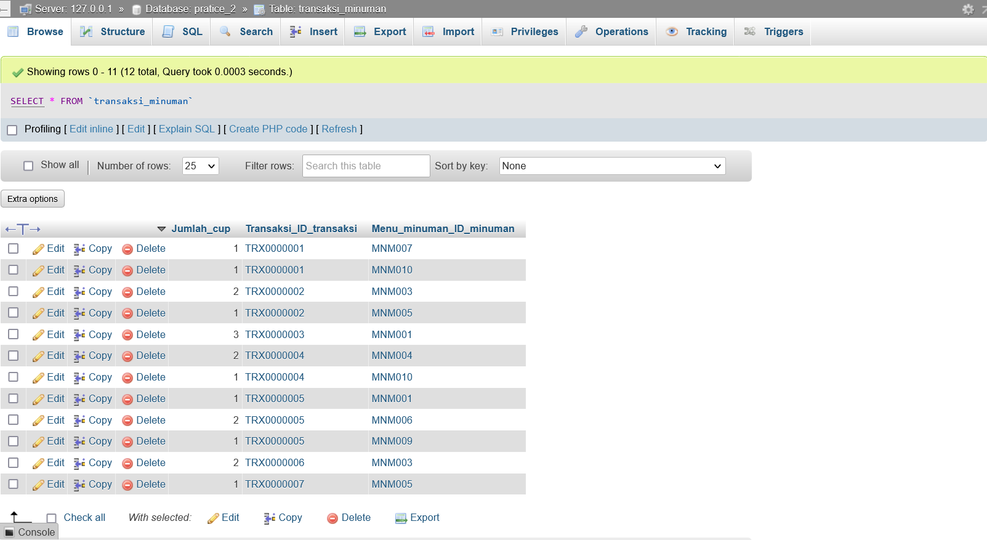

**Nomor 6**

Sintaks:

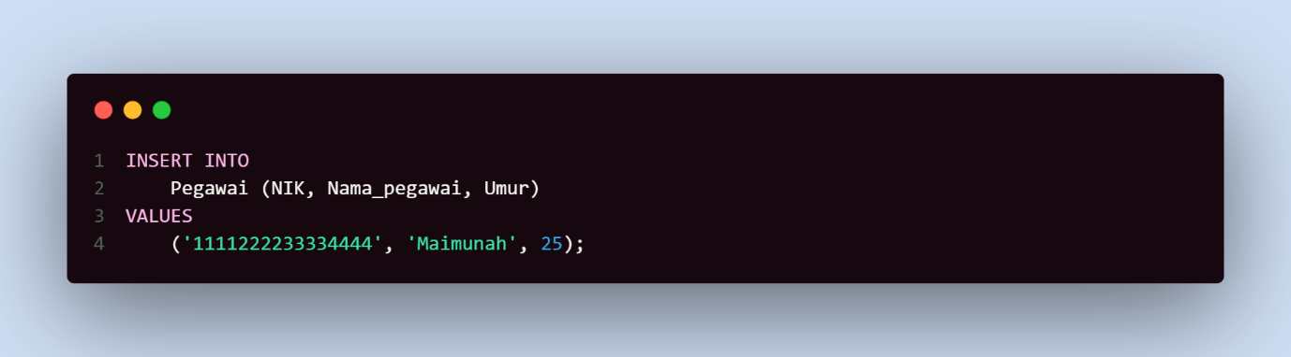

Hasil:

Pegawai updated  
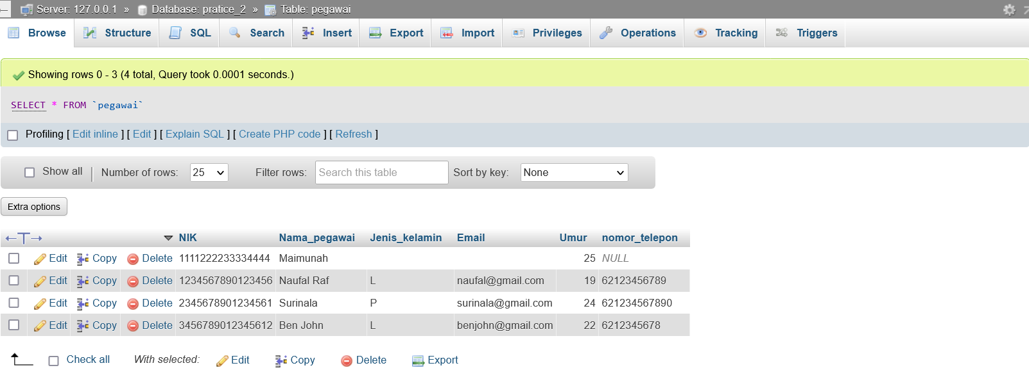

**Nomor 7**

Sintaks:

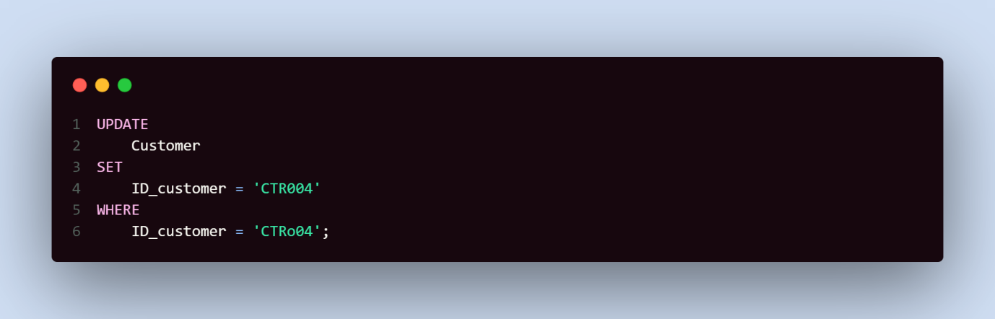

Hasil:

Customer updated  
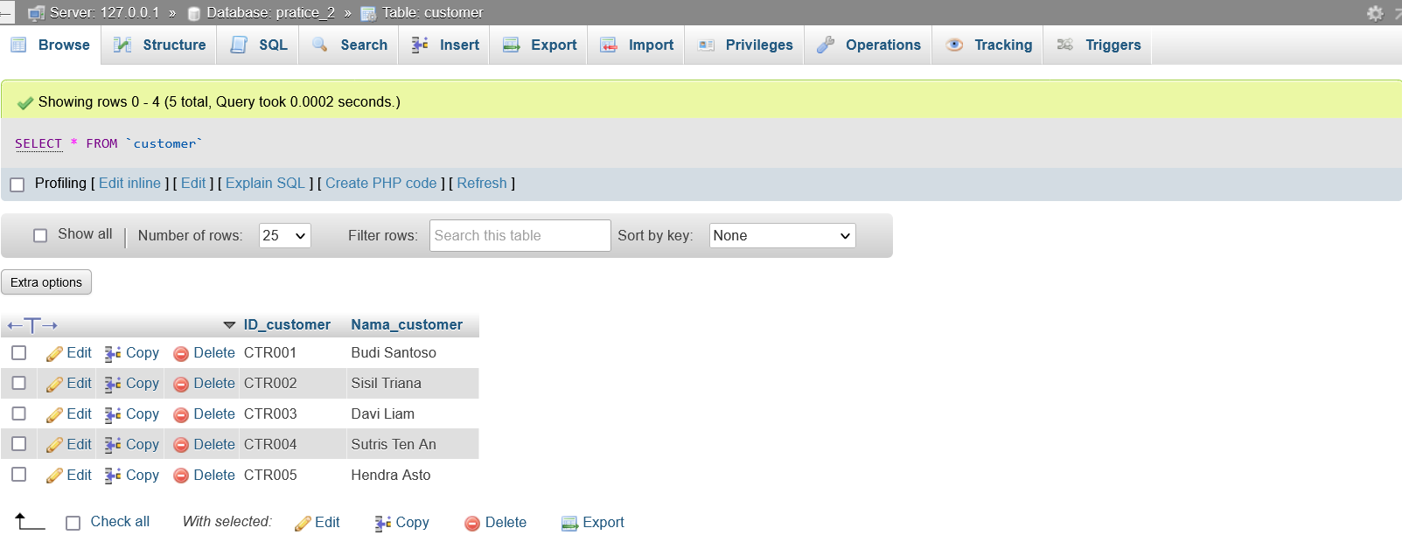

**Nomor 8**

Sintaks:

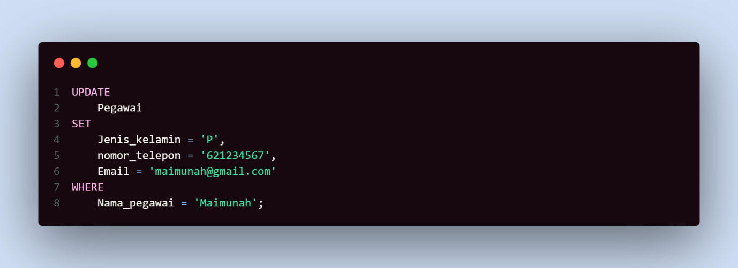

Hasil:

Pegawai updated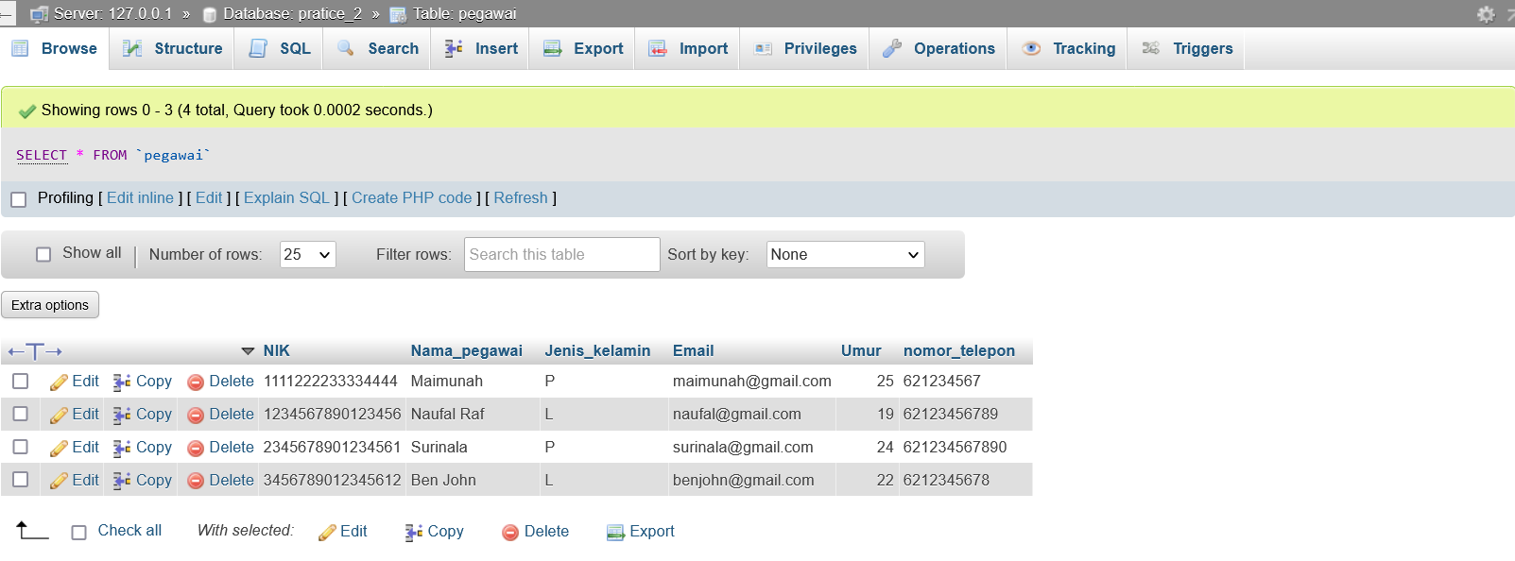**Nomor 9**

Sintaks:

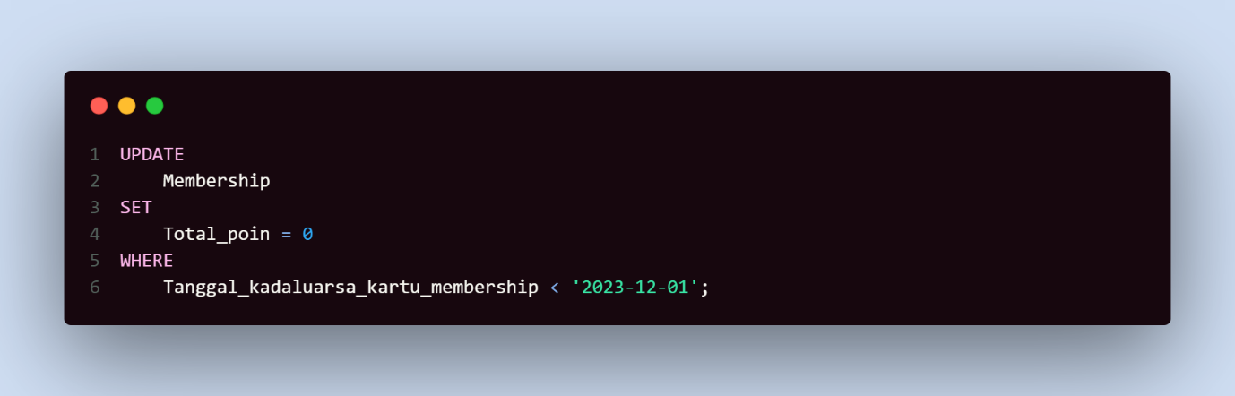

Hasil:

Membership updated  
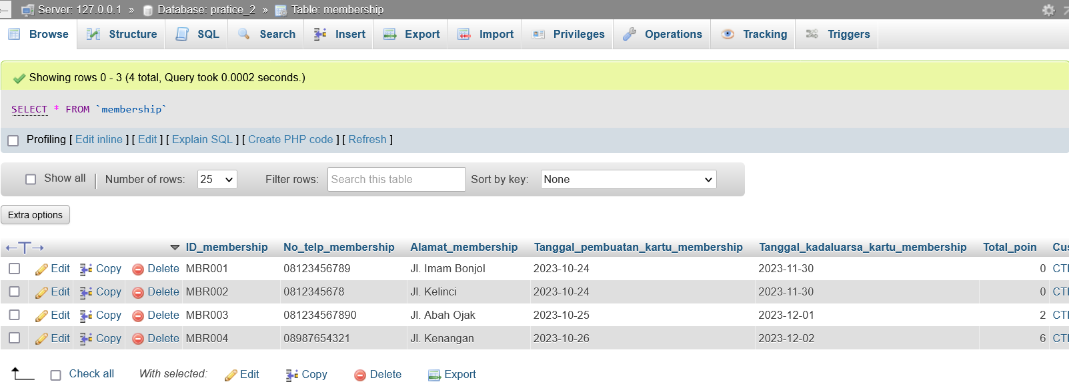

**Nomor 10**

Sintaks:

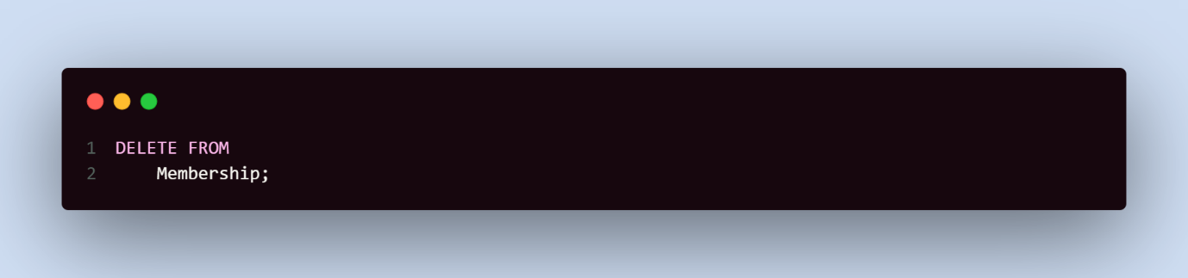

Hasil:

Membership data deleted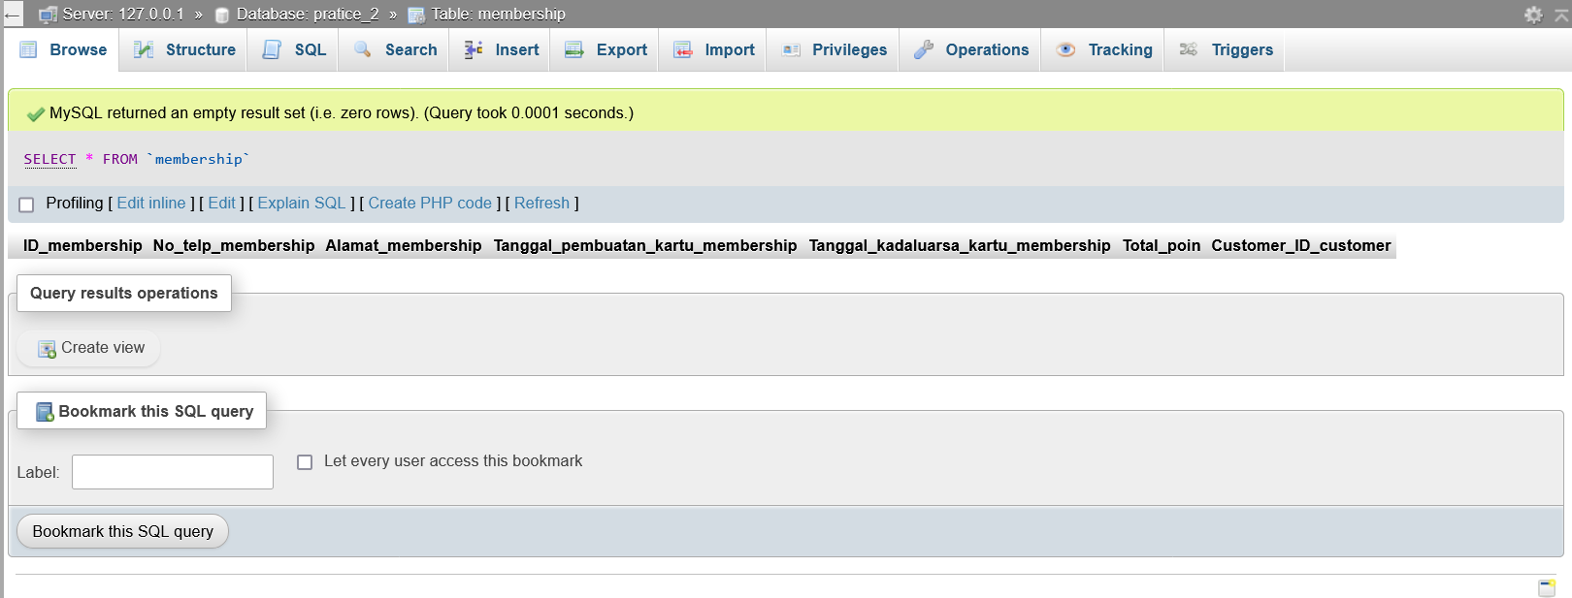

**Nomor 11**

Sintaks:

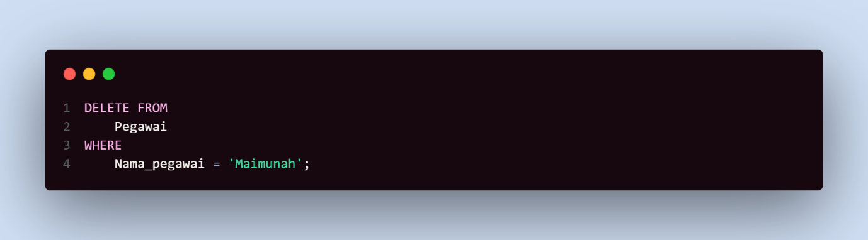

Hasil:

Maimunah Deleted